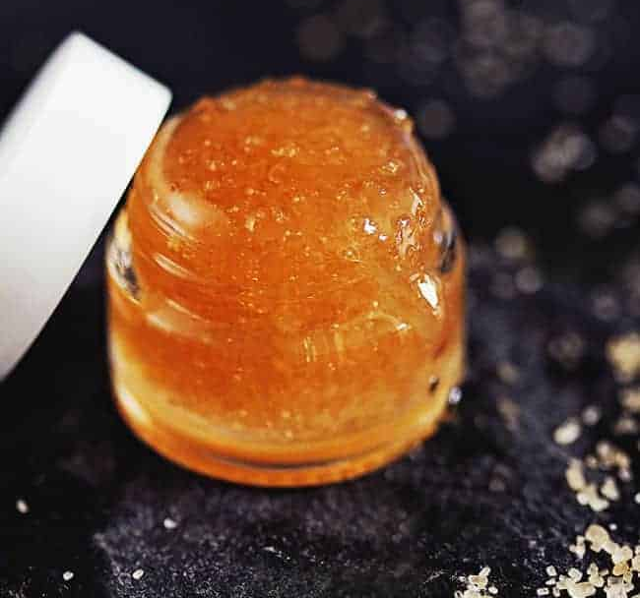
DIY Lip Scrub

Ingredients:
- 1 teaspoon honey
- 2 teaspoons sugar (try Brown Sugar!)
- ½ teaspoon oil (like Olive Oil, Almond Oil, or Coconut Oil)

Mix together in a bowl and use, massage into lips with finger tips then rinse with warm water, finish with some lip balm!

Try other additives:
- Vanilla Extract- no more than a teaspoon, but make it even more edible if you are concerned about flavor on the lips with the oils
- A small dash of Cinnamon or Cayenne- be very careful as too much can be irritating but helps with plumping
- A small bit of a citric fruit (Strawberry suggested)- for polish

DIY Oat and Honey Face Mask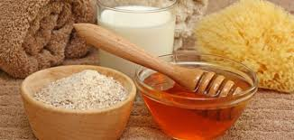
Ingredients:
- 1 tablespoon rolled oats
- ½ teaspoon of honey
- ¼ cup greek yogurt (optional)

Mix together in a bowl, apply to face with hands and leave on for 10-15 minutes, and rinse off with warm water. Giving you a cool, calm glow!

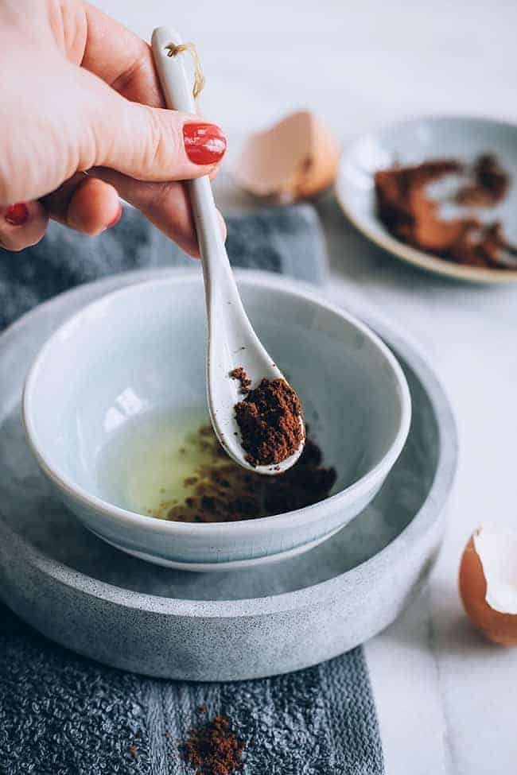
DIY Coffee Eye Mask
Ingredients:
- 1 tbsp oil (jojoba, olive, rosehip)
- 1 tbsp used coffee grounds

Combine ingredients in a bowl, mix together thoroughly until it creates a paste. Apply around eyes avoiding lid with fingers, allow to dry for 10 minutes, use warm water to rinse with a soft cloth, finish with a moisturizer. Tight and firm skin around the eyes to reduce puffiness!

