More information / contact: Kiki Dreyer Burke
PR Manager, Campbell County Public Library
859-781-6166, ext. 11
kdburke@cc-pl.org

DROP YOUR DRAWERS FACT SHEET
Information Updated Dec. 12, 2016

TITLE OF PROGRAM:
Drop Your Drawers at the Campbell County Public Library

DETAILS:
Children’s underwear donation drive – asking people to donate packages of new underwear for boys or girls in sizes 4-16. Underwear will be donated to Family Resource Centers in all 14 public elementary schools in Campbell County.

DATE: Now through Dec. 31.

GOAL: Collect 6,000 pair of underwear.

CURRENT STATUS: 4,301 pair collected

DROP OFF LOCATIONS:
Cold Spring Branch: 3920 Alexandria Pike
Carrico/Fort Thomas Branch: 1000 Highland Ave.
Newport Branch: 901 E. Sixth Street

PURPOSE:
- Educate public about a real need in our schools. Being able to provide new underwear will help keep children in the classroom.
- Goal of Family Resource Centers is to minimize non-cognitive factors that keep kids from learning.
- Need is great. 30-100 pair of underwear are given out every month at some schools to children in need.
- Children need underwear at school for a variety of reasons including accidents, illness, underwear not available at home, inability of family to wash clothes regularly, homelessness, children who dress themselves inappropriately, family issues, etc.

ADDITIONAL INFORMATION:
- Video clip from our website shows interviews with two Family Resource Center coordinators, Molly Wesley at Newport Primary School and Kriste Swanson at Cline and Crossroads Elementary Schools. See it at http://www.cc-pl.org/drop-your-drawers.
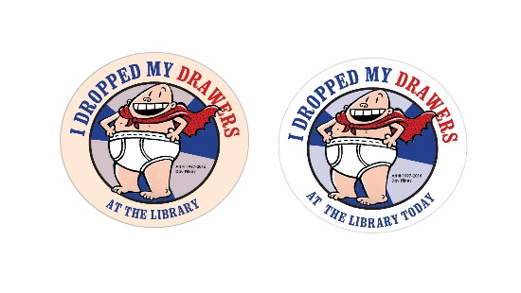
- A person receives a “I dropped my drawers at the Library” sticker every time they donate a package of underwear.
- This is second year for the underwear drive. Last year Campbell County raised more than 5,000 pair.

CAMPBELL COUNTY SCHOOLS:
Public elementary schools in Campbell County that will receive the underwear are (in alphabetical order):
- Campbell Ridge
- Cline
- Crossroads
- Grandview
- Grant’s Lick
- Johnson
- Lincoln
- Moyer
- Newport Intermediate
- Newport Primary
- Reiley
- Silver Grove
- Southgate
- Woodfill

VISUAL ELEMENT
The image of Captain Underpants, a character in a series of popular children’s books, is copyrighted material and used with permission by author Dav Pilkey and his publisher, Scholastic.

OTHER PARTICIPATING LIBRARIES
- Kenton County Public Library goal 6,000
- Boone County Public Library goal 4,200
- Grant County Public Library goal 1,000
- A total of 51 public libraries throughout Kentucky are participating in the 2016 Drop Your Drawers fundraising campaign.

